Thank you for buying the **Military & survival damage indicator pack**, we hope it will help you in your project.

If you liked our product, do not forget to rate it in an Asset store: <http://u3d.as/25Jz>.

Your feedback will help me improve the project.

If you have any suggestions or questions, you can write to this email: [*pirate.parrot.software@gmail.com*](mailto:pirate.parrot.software@gmail.com)

**Changing the fill and outline color instructions**

To get started, you need the Layers tab. If it is closed, then do the following:

Windows - Layers or press (F7).

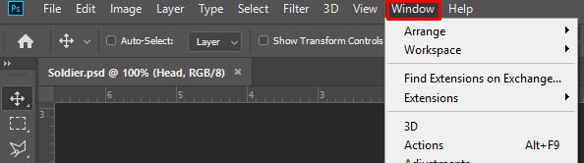

In the Layers panel, expand the folder with the desired object. To do this, click on the arrow to the left of the Folder image.

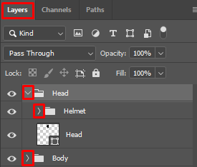

In the Tools Panel, select Pen or press (P). If the panel is closed, Windows – Tools.



Select the Layer on the Layers Panel which you want to work with by clicking on it.

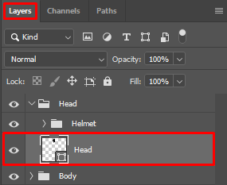

After you turned on the Pen tool and selected a layer, the color settings for this layer will appear.

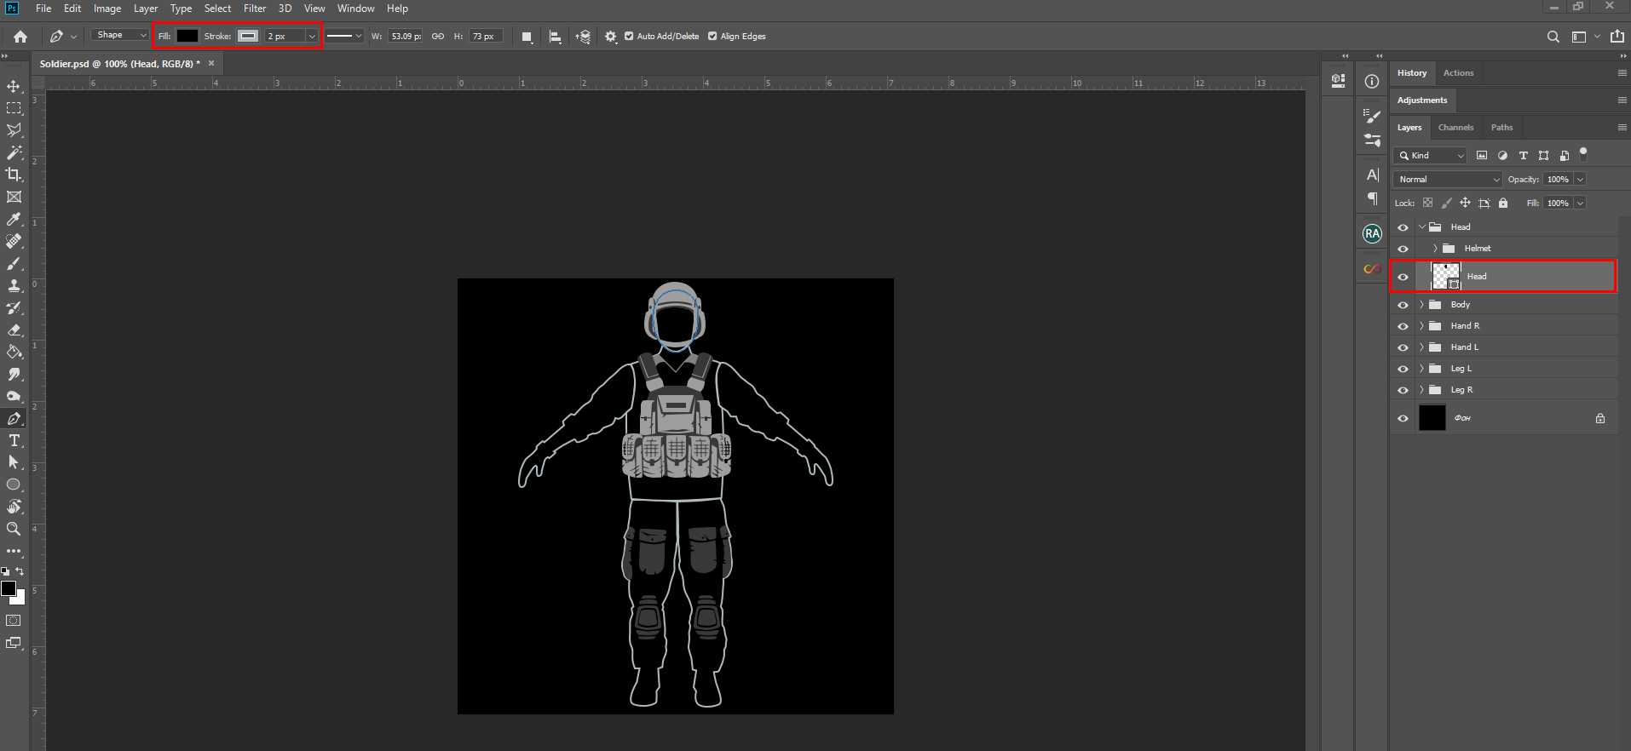



Fill, outline color and outline thickness. Click on the color icon to change it.

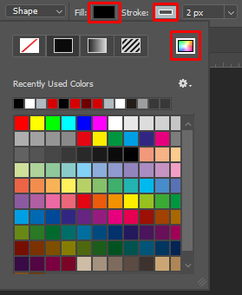

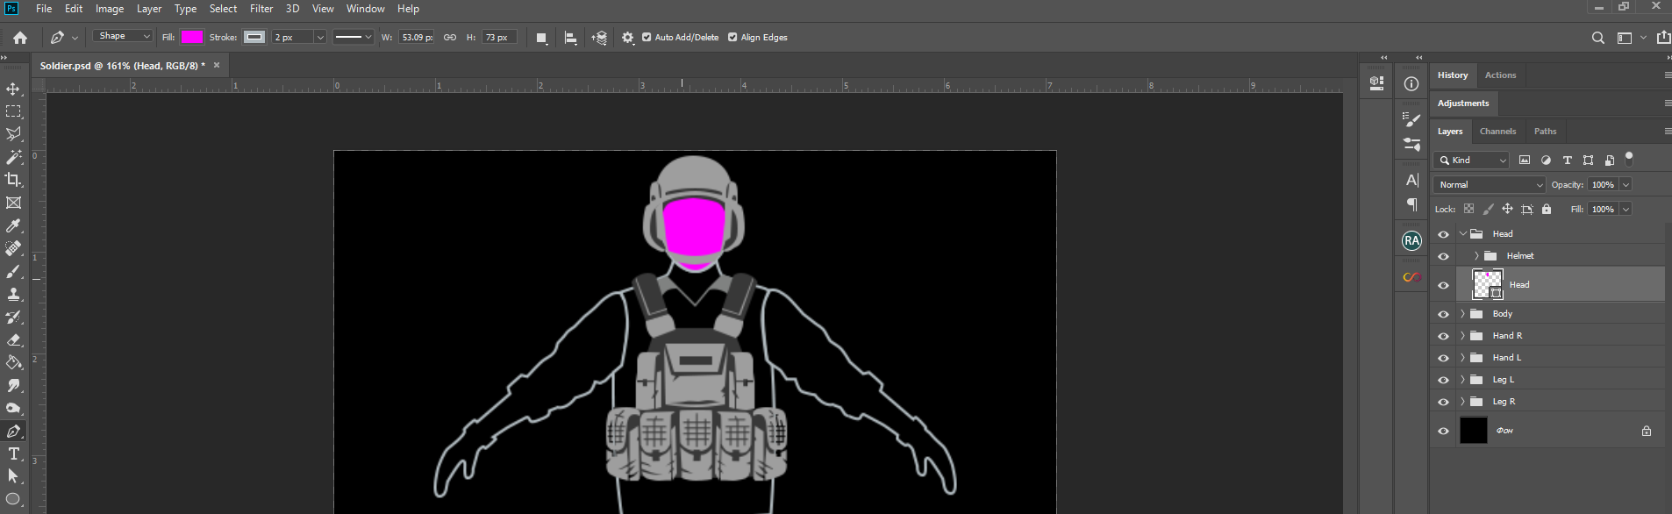

***Ctrl + H*** - Remove the extra stroke (selection) from the object.

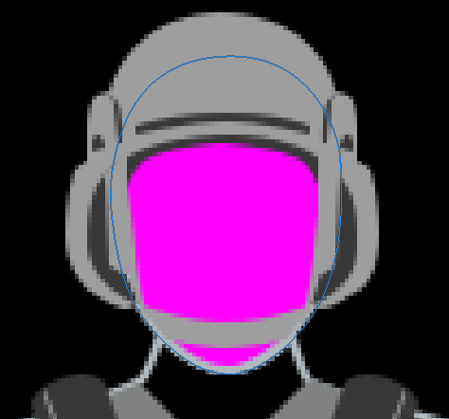

Thank you for buying the **Military & survival damage indicator pack**, we hope it will help you in your project.

If you liked our product, do not forget to rate it in an Asset store: <http://u3d.as/25Jz>.

Your feedback will help me improve the project.

If you have any suggestions or questions, you can write to this email: [*pirate.parrot.software@gmail.com*](mailto:pirate.parrot.software@gmail.com)